Lab Task # 5
Q1. Write a program that prints a 5×5 grid of alphabets (A to E in each row) using nested for loops.
Solution:
#include<iostream>
using namespace std;
int main() {
int a;
char n;
for (a = 1; a <= 5; a++)

{
for (n = 'A'; n <= 'E'; n++)
{
cout << n;
}
cout << endl;
}
return 0;
}

Q2. Write a program that prints an inverted right triangle pattern of stars using nested for loops.
Solution:
#include<iostream>
using namespace std;
int main() {
int s, t;
for (s = 5; s >= 1; s--)
{

for (t = 1; t <= s; t++)
{
cout << "*";
}
cout << endl;
}
return 0;
}

Q3. Write a program using nested for loops to display all possible two-digit combinations of numbers within the range 1 to 4.
Solution:
#include <iostream>
using namespace std;
int main() {
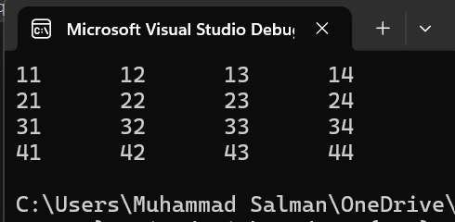
for (int a = 1; a <= 4; a++)
{
for (int b = 1; b <= 4; b++)
{
cout << a << b<<"\t";
}
cout << endl;
}
return 0;
}

